Syeda Reeha Quasar

14114802719

4C7

Aim

Write a program to find the greatest of two given numbers in two different classes using friend function.

Experiment - 8

Object Oriented Programming Lab

# **EXPERIMENT – 8**

## **Aim:**

Write a program to find the greatest of two given numbers in two different classes using friend function.

## **Source Code:**

#include <iostream>

using namespace std;

class ClassB;

class ClassA {

    private:

        int numA;

        friend int greatest(ClassA, ClassB);

    public:

        void input() {

            cout << "Enter number for class A:";

            cin >> numA;

        }

};

class ClassB {

    private:

        int numB;

        friend int greatest(ClassA, ClassB);

    public:

        void input() {

            cout << "Enter number for class B:";

            cin >> numB;

        }

};

int greatest(ClassA objectA, ClassB objectB) {

    return max(objectA.numA, objectB.numB);

}

int main() {

    ClassA objectA;

    ClassB objectB;

    objectA.input();

    objectB.input();

    cout << "Greatest: " << greatest(objectA, objectB);

    return 0;

}

## **Output:**

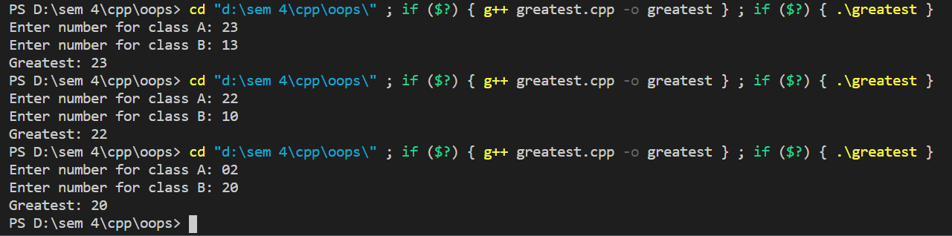



# **Viva Questions**

### Q1) What is an overflow error?

Ans.

It is a type of arithmetical error. It happens when the result of an arithmetical operation been greater than the actual space provided by the system.

### Q2) What is overloading?

Ans.

* When a single object behaves in many ways is known as overloading. A single object has the same name, but it provides different versions of the same function.
* C++ facilitates you to specify more than one definition for a function name or an operator in the same scope. It is called function overloading and operator overloading respectively.
* **Overloading is of two types:**

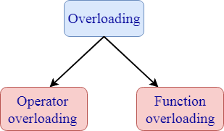

* 1. **Operator overloading:** Operator overloading is a compile-time polymorphism in which a standard operator is overloaded to provide a user-defined definition to it. For example, '+' operator is overloaded to perform the addition operation on data types such as int, float, etc.

**Operator overloading can be implemented in the following functions:**

* Member function
* Non-member function
* Friend function

**Syntax of Operator overloading:**

Return_type classname :: Operator Operator_symbol(argument_list)

{

      // body_statements;

}

**2. Function overloading:** Function overloading is also a type of compile-time polymorphism which can define a family of functions with the same name. The function would perform different operations based on the argument list in the function call. The function to be invoked depends on the number of arguments and the type of the arguments in the argument list.

### Q3) What is function overriding?

Ans.

If you inherit a class into a derived class and provide a definition for one of the base class's function again inside the derived class, then this function is called overridden function, and this mechanism is known as function overriding.